
National University of Computer & Emerging Sciences, Karachi
FALL-2021 CS-Department
Final Exam
4th of Jan 2021, 06:00 pm – 09:00 pm
Course Code: CS301 | Course Name: Theory of Automata
Instructor Name: Mr. Musawar
Student Roll No:

Instructions:
- Return the question paper.
- Attempting of the question in the given order is highly encouraged.
- Read each question completely before answering it. There are 6 questions on 3 pages.
- In case of any ambiguity, you may make assumption. But your assumption should not contradict any statement in the question paper.

Time: 180 minutes. Max Marks: 160 points

Question 1: Regular expression & Properties (5+5) Points
a) Give the equivalent REs for the following regular expressions other than the given one.
1. (bbb)* a (bb)*+ (bb)* a (bbb)*
2. a*(a+b)*a* + b*(a+b)*bb*

b) Let L₄ = L₁ ∩ L₂. If L₁ is context free and L₂ is context, then L₄ is not context free. Discuss with an example.

Question 2: Finite Automata (10+10+10) Points

- Find out the union and intersection using Kleen’s Theorem of the following FAs.

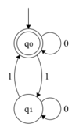 | 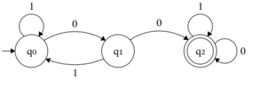

b) Convert the following NFA to equivalent DFA.
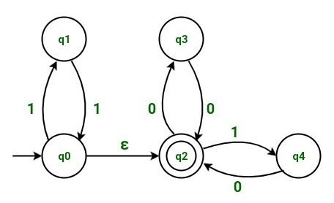
c) Minimize the following DFA using the method of your own choice.
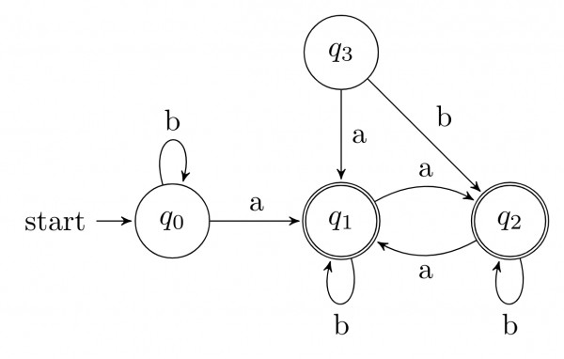
Question 3 (a): CFG (5+5+5+5) Points
Construct a CFG which generates the following languages:
- L4 = { 0^{i}1^{j}2^{k}| I >=2,j,k>=0}
- L1 ={ 0^{i}1^{j}2^{k}|j <=i }
- L2 ={ 0^{i}1^{j}2^{k}|j <=k }
- Find L3 = L1∪L2
Question 3 (b): CFG (10) Points
Check the ambiguity in the following grammar with the help of at least 3 derivation trees.
E -> I
E -> E + E
E -> E * E
E -> (E)
I -> ε | 0 | 1 | 2| 3 | 4 | 5 | 6 | 7 | 8 | 9

Question 4: CNF (10+10) Points
Consider the following CFG for non-empty language:
S→ASA│BSB│AA│BB│A│B
S→ASA│BSB│AA│BB│a│b
Q→CA│DB│AA│BB│a│b
N → ab |AS | ε
M → bS| Cab| ε

- Simplify showing each steps clearly.
- Convert the above CFG into CNF.

Question 5: P.D.A. (10+10) Points
- Identify language of given CFG, construct a P.D.A. and trace the input string ------ using stack :
S→ 0S111| 0S1111 |^
Trace the input string "0011111" using stack. Is the string accepted by the grammar?

- Construct a PDA for language L ={ a^{n}b^{m}c^{k}d^{l}|n+m = (k+l)/2 ≥0}. Trace the input string, which belong to language (length of string should be at least 6) using stack.

Question 6: Turing Machine. (10+10+5) Points
a) Design Turing machine for language:
- L = {0^{n}1^{m}2^{n} | 2m<=n<=4m}
- L = { abc (a + b)*cba}
- Draw Chomsky Hierarchy and discuss.
b) Give Pseudocode and its corresponding TM for the following functions:
(15+10) Points

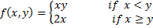
- A = {0^{n} | n is a power of 3}

BEST OF LUCK!

